INDEX

1. ~~Uploading Terms Issue - Matt explained this is due to the file uploading timing out.~~
2. Uploading Terms – Supplier Fixed Field
3. Uploading Terms/Allocating to Members – Field required showing which members the uploaded terms have been allocated to.
4. Supplier Price List file in media, can’t pick up the file when trying to link in supplier page tab. I am still unable to pick up the uploaded file for linking in supplier page tab. : MH Testing
5. Main Folders in Media have a delete restriction. In Progress
6. Duplicate Supplier Folders in Media – In Progress
7. Supplier Homepage – bullet lists
8. Supplier Keywords field limit - Fixed
9. Manage Companies – Member/Supplier radio buttons default – Developers unable to replicate issue.
10. Supplier view – File links and text colour. Fixed
11. Supplier search – Font colour. Fixed
12. Product Search – Country UF. Country UF product word search sorted, see issue 18 for new issue
13. Product Search – Logo size. Fixed

1. Member/Supplier access. Not Fixed : **In Progress**
2. Manage Terms/member and supplier access. Not Fixed : **In Progress (as discussed in call – we will add a link in the Manage Terms list page so that you can see a popup list of the email addresses that will receive the terms – example in the image attached to the mail)**
3. Manage Companies – Table in Homepage for text and images - Fixed
4. Deleting a member view from published files. Not Fixed : **Being Tested**
5. Duplicate Country UF companies in product search – **NEW ISSUE**
6. Uploaded the terms, allocated to members and when trying to save it takes ages then kicks Susan out. She has reported this issue before. I have looked in manage terms and the terms Susan uploaded are there but only showing as allocated to some members and not all the members that Susan chose (only Aspatria to JS Hubbuck). See unpublished terms supplier Agrimin. *Two days later I was going to take a screen shot of the file to put in these notes when I noticed that all the members Susan chose were now showing. We are confused as to why.*

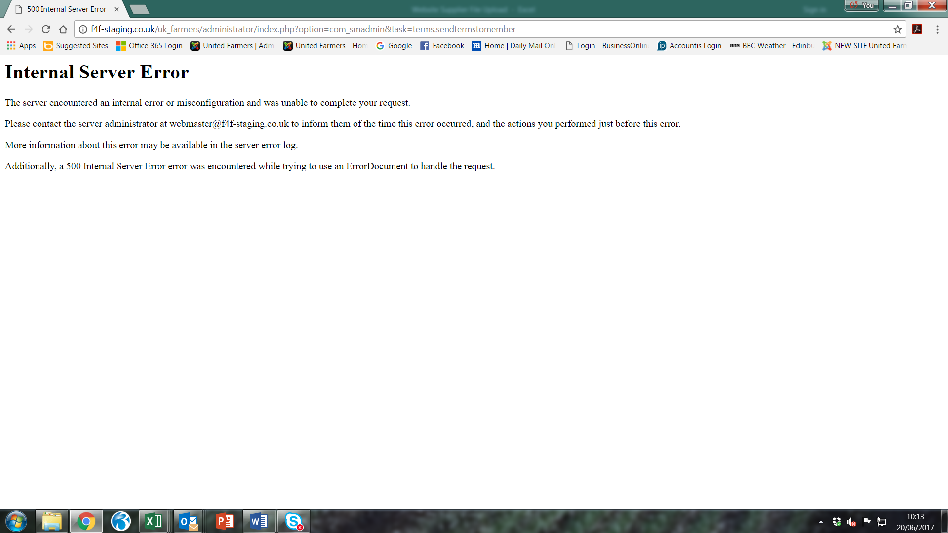

1. In UF Admin/Manage Terms/New/Allocate terms to members the select supplier field should be a fixed field showing the supplier whose terms you are uploading and allocating terms to members.
2. When terms have been uploaded and allocated to members, can we have a field that shows which members the terms have been allocated to.

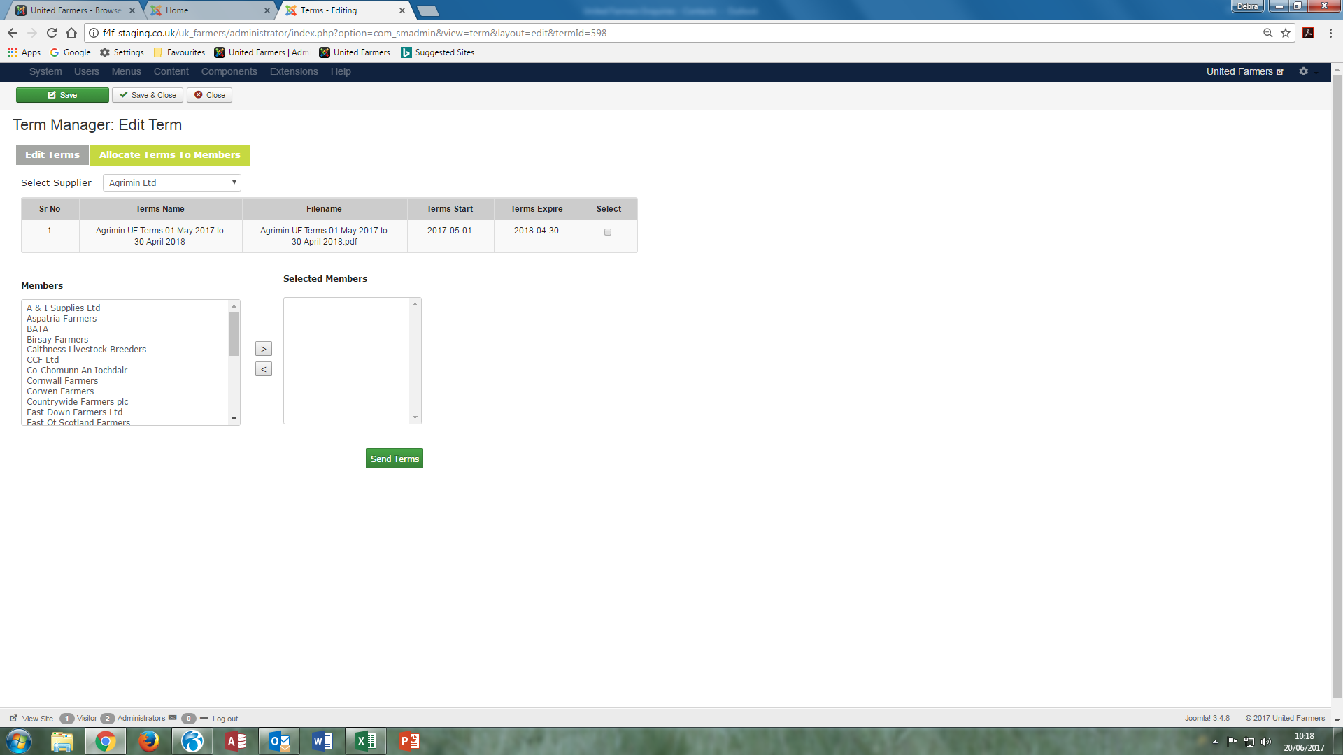

Field required to show which members the terms have been allocated to.

Should be a fixed field

1. Supplier, Quicktag price list uploaded as a file link in the price list tab. As discussed on 13th June, I am unable to pick up existing files while in the suppliers’ page tabs.
2. In Media, can the folders that contain Country UF, Members and Suppliers not have the ability to be deleted but the content within the folders be able to be deleted.
3. Duplicate supplier folders still being created if I make any amendments. Some of the duplicates are members that are also suppliers. I took out all brackets in supplier company names a couple of weeks ago but noticed some of the duplicates are supplier company names with brackets. Not sure if new folders being created when data being brought over from current live site to new site! Also noticed if I upload a 2nd logo to a supplier this is creating a duplicate folder.

Aspatria Farmers Ltd – Supplier x2  
Badminton Feeds – John Loader Wessex x2  
Countrywide Farmers plc – Supplier x2  
CPL Distribution – Supplier x2  
Decco – Devon x2  
Decco – Stuart & Mackintosh x2  
Dickies UK x2  
East of Scotland Farmers – Supplier x3  
Fane Valley – Supplier x2  
Furness & South Cumberland – Supplier x2  
Greenmount Country Stores – Supplier x2  
Hampton Steel Ltd x2 – *I changed the name from Hampton Steel & Wire to Hampton Steel Ltd and it created another folder.*Harbro Ltd – Supplier x2  
Hunter Wilson x2  
JCB Clothing x2  
South West Lancashire Farmers – Supplier x2  
Tarff Valley Supplier x 2  
Trouw Nutrition GB x2  
Trouw Nutrition Ireland x2  
TruTest Agtech x2

1. UF Admin/Manage Companies – Supplier homepage text. Not able to use bullets as icon not working.
2. Manage Companies/New – Supplier keywords. Is there a limit to number of keywords as Gallagher Power Fence cutting off?
3. Manage Companies/New – As per email dated 15/06/2017. Is there a default in the member/supplier radio buttons? I was in supplier A W Jenkinson amending the font and font size, saved and when I logged in as a member to view the changes the supplier was not on the supplier search. When I looked in UF Admin the radio button was now at member not supplier.
4. Logged in as a supplier, can all file links be green and the other text be grey the same as a member view?

Sent to field to be in green font

File description link to be in green font

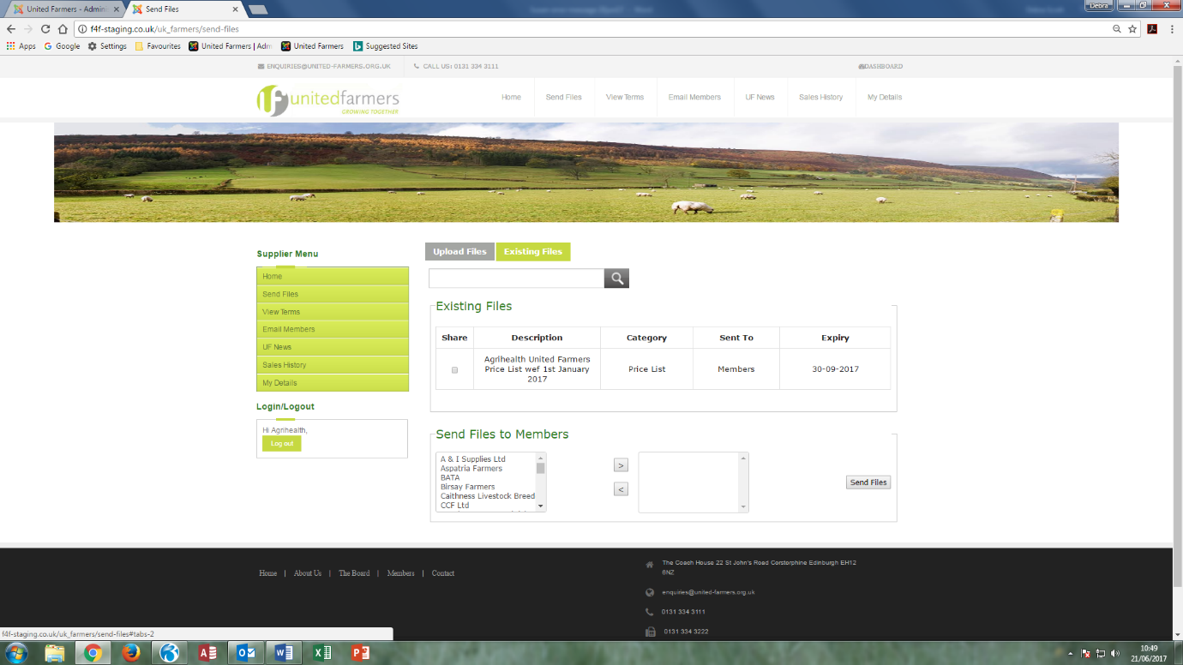

1. Logged in as a member, supplier search – When a supplier is clicked on and shows supplier mini site, can the name of the company be in grey font the same as in supplier search.

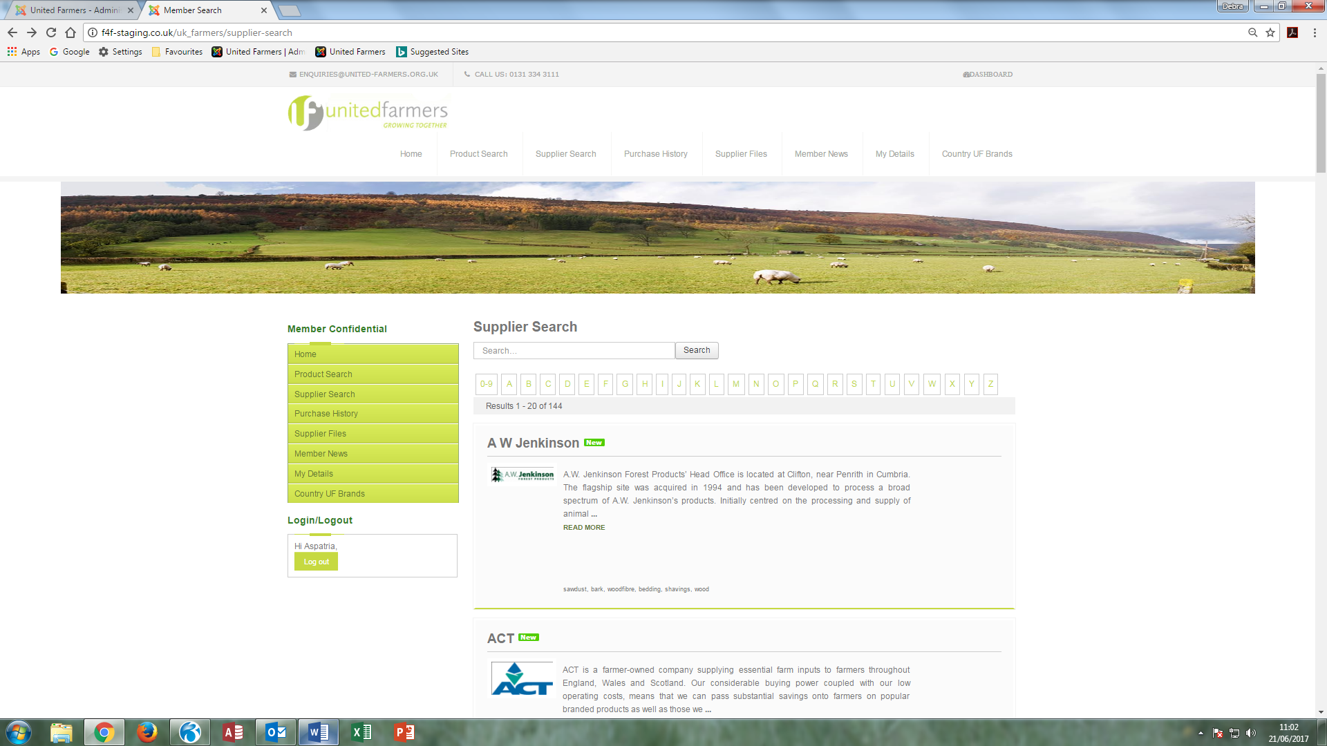

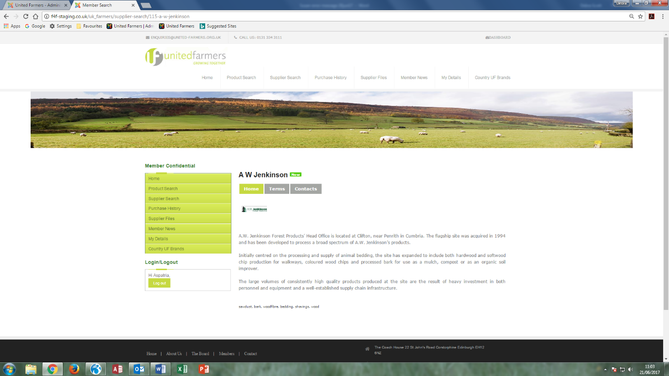

1. 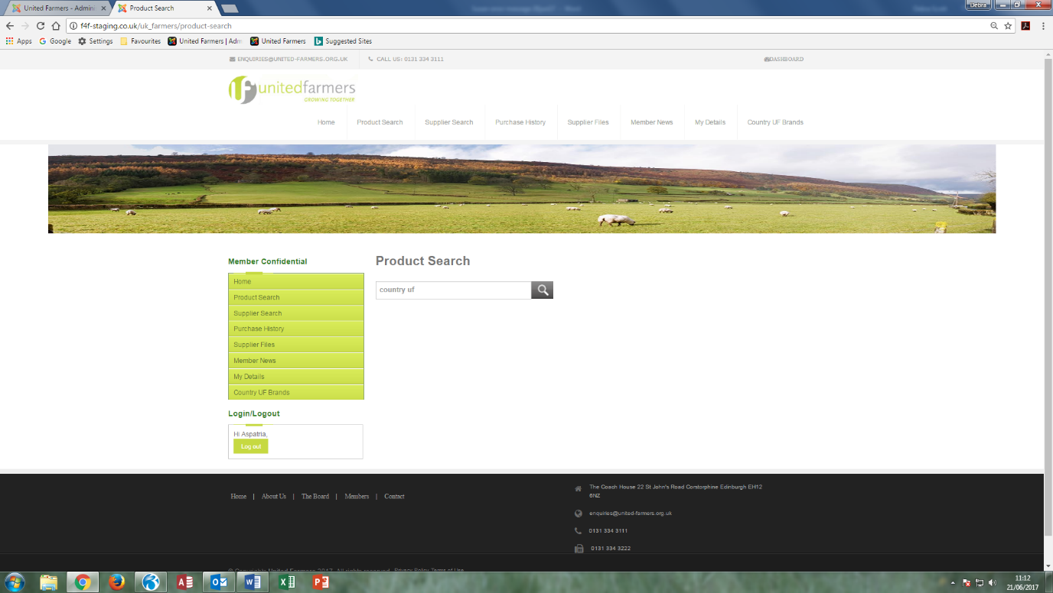Product search – Country UF. I have entered the keyword country uf in some suppliers who provide us with the Country UF Brand but when logged in as a member I search on country uf the search is not bringing back any data.
2. 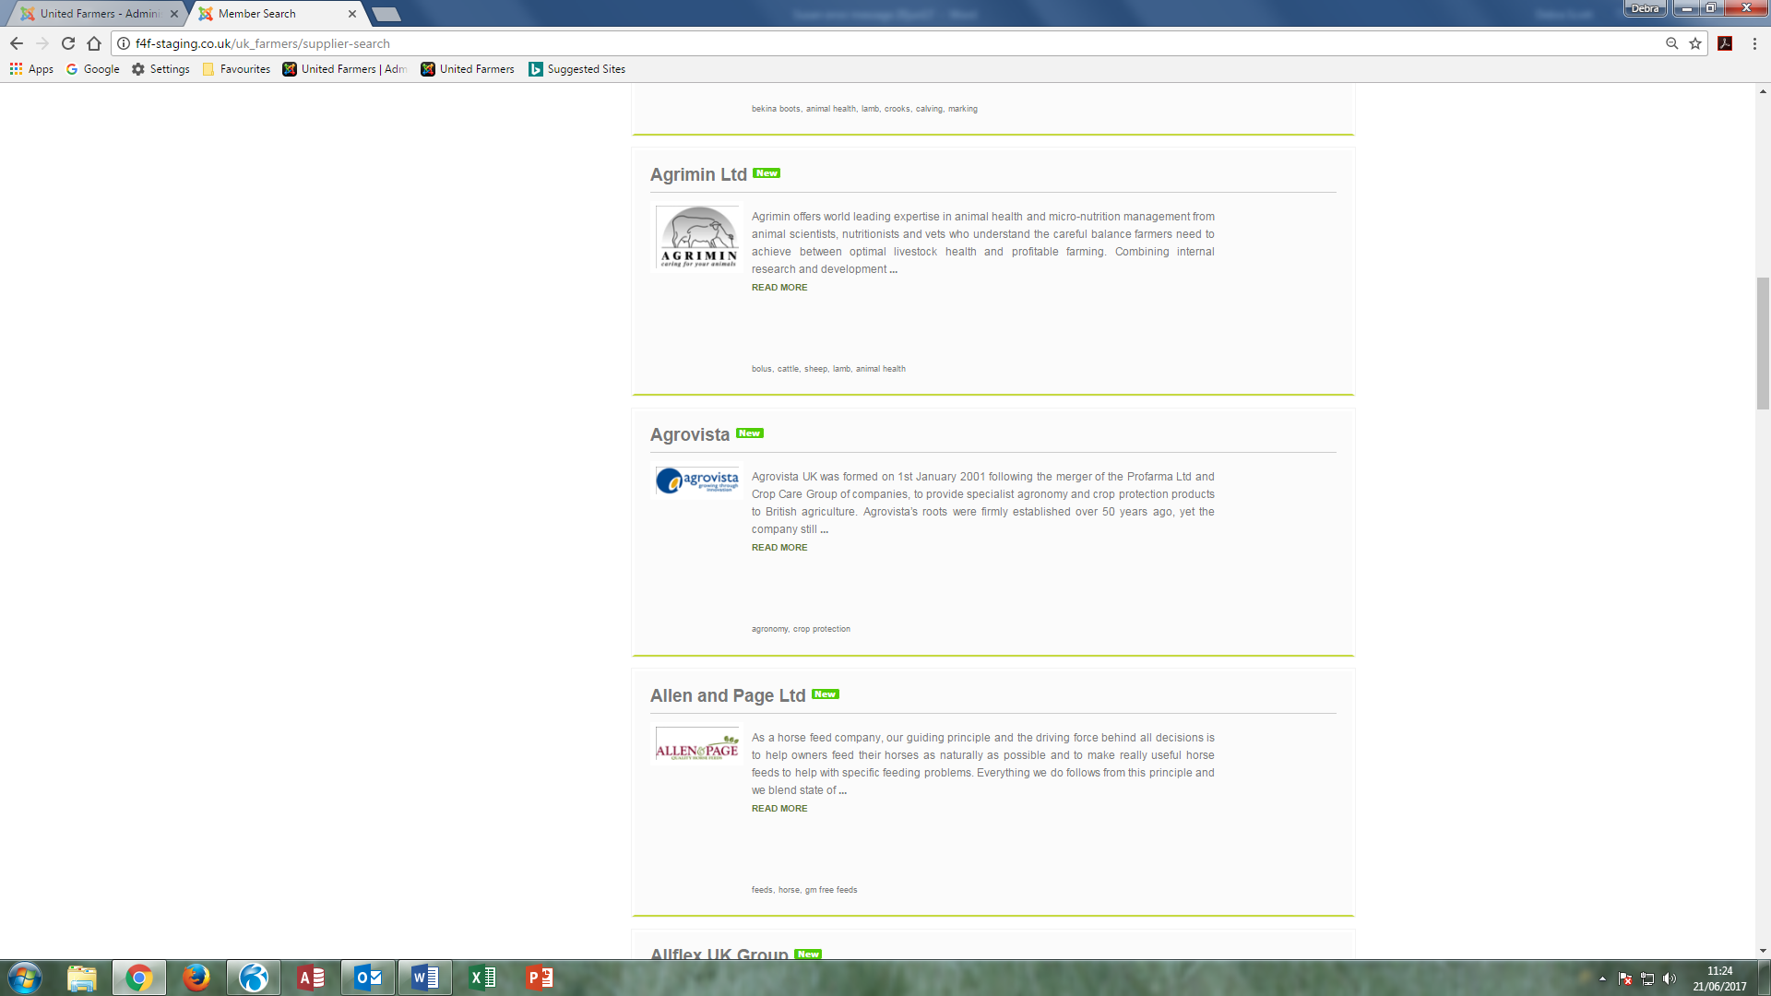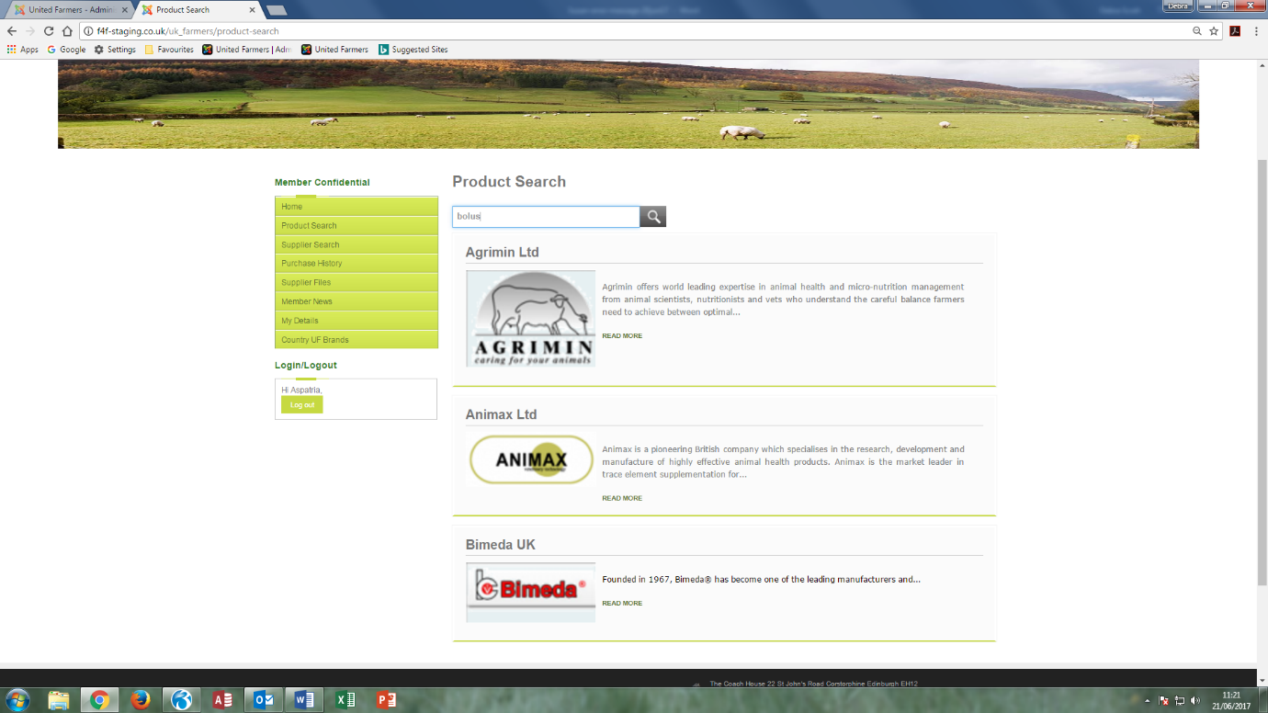Product search – Logo size. When logged in as a member and click on product search and enter a product the supplier logos on the data it retrieves are big and pixelated. Can the logos show the same size that is in supplier search?

Supplier Search

1. Member/Supplier access – Has the contact list from current live site populated the new website? Agrimin/BATA showing with no email alerts for any user but on current live site 3 BATA users get email alerts. This is just one instance, there are many more.
2. Manage Terms – Uploaded terms not showing with correct email addresses for the email alerts. They are showing with company [name@united-farmers.org.uk](mailto:name@united-farmers.org.uk) but these are not the emails of the users that have been chosen in member/supplier access?

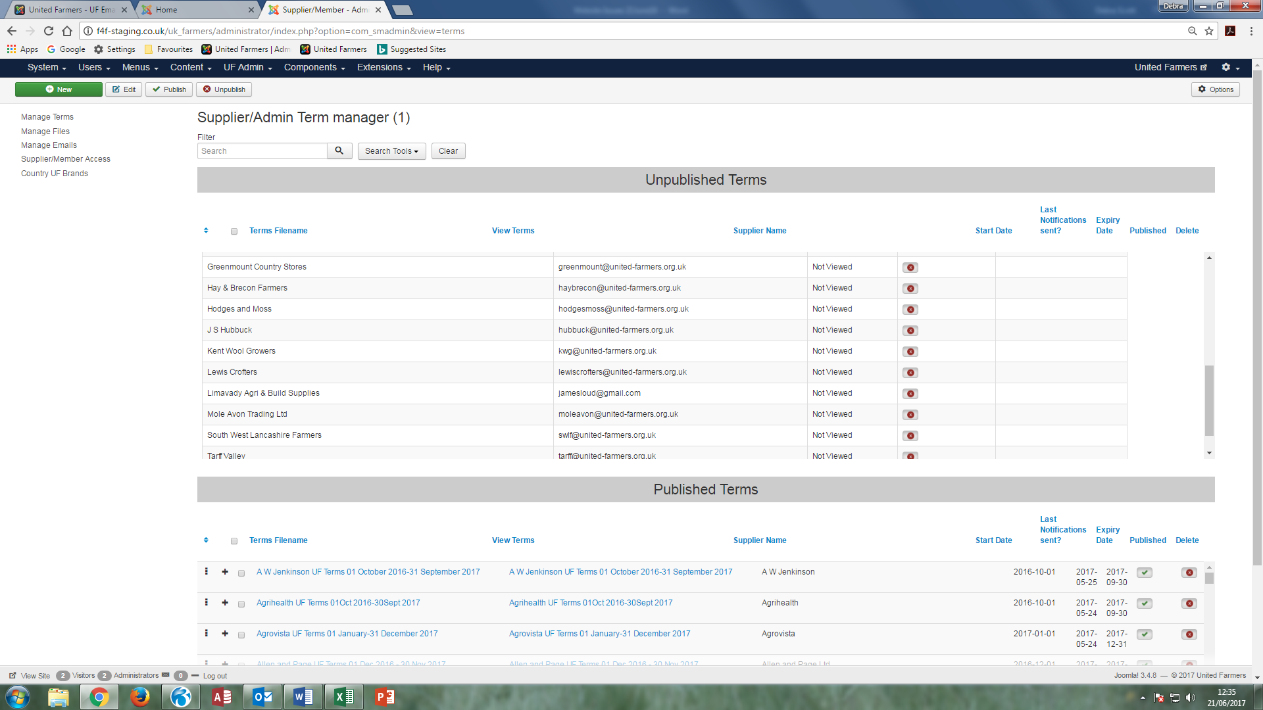

1. Manage Companies – Please remove the grey lines when a table is inserted in the supplier’s homepage for text and images.

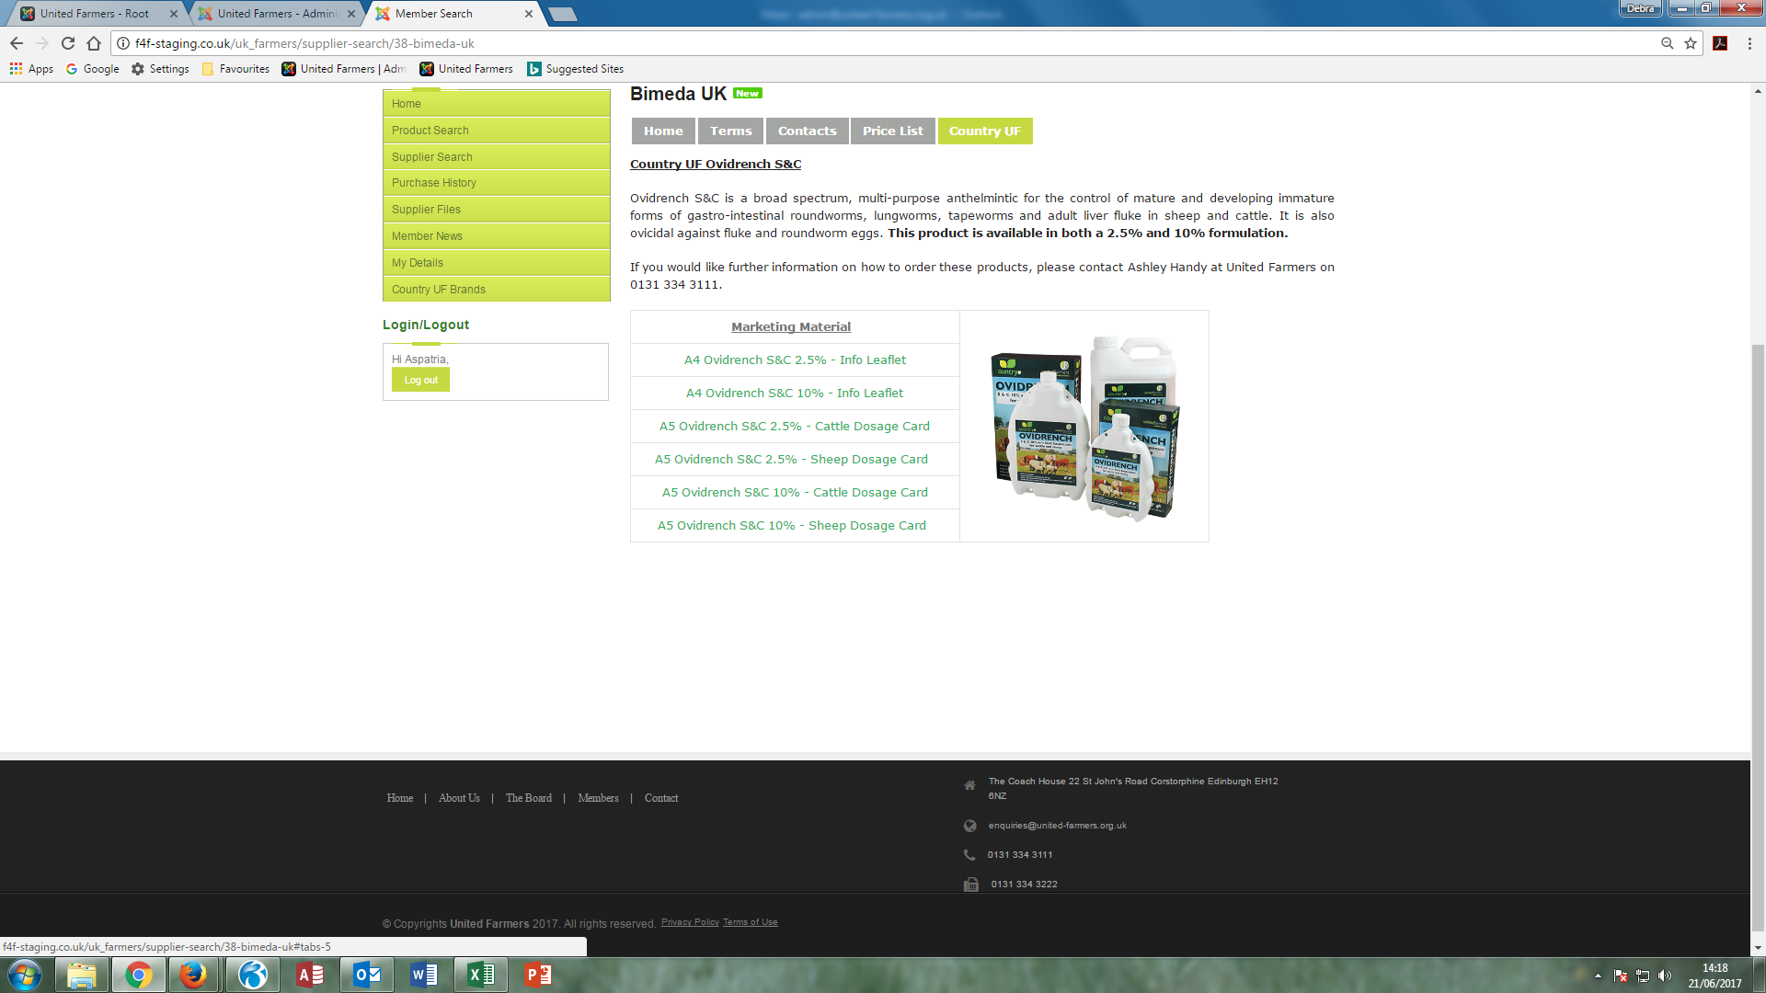

1. In Manage Files/published files there is a price list file been allocated to a member it shouldn’t have and I want to delete their view. There is a field delete member view but it does not work. The supplier is Bunzl, the file is [Bunzl UF Price List 01Feb17-28Feb18](http://f4f-staging.co.uk/uk_farmers/uf_data/suppliers/bunzl_cleaning_and_hygiene_supplies/pricelists/Bunzl%20UF%20Price%20List%20wef%2001%20Feb%202017.pdf) and the member I want to delete is Cornwall Farmers. I can see how we would be able to delete a user within a membership once they have opened it but not how to delete the member as a whole from viewing.

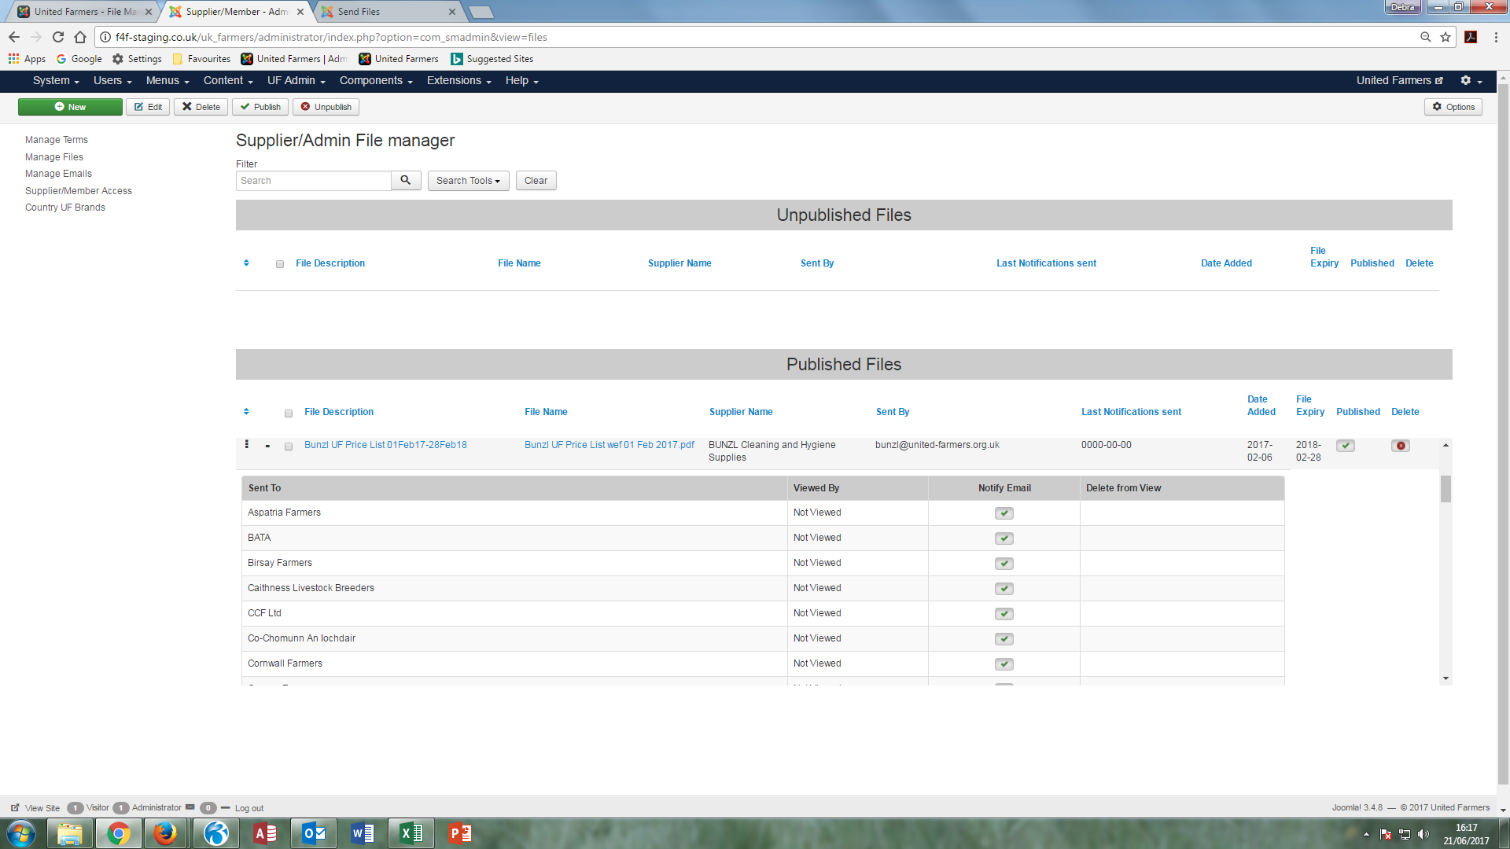

1. Logged in as a member and click on product search and enter keyword country uf. This brings back duplicate companies of the suppliers that have the Country UF logo in. I have only uploaded the Country UF logo for BATA and CPL Distribution. Both those companies are showing twice, one with their own logo and again with the country uf logo.

